# Freestyle war project pipeline – Jenkins

## Pre-requisites:

Tomcat must be running on the appropriate port and the require role/user changes must be made on the server.xml and tomcat-users.xml

Tomcat reference repo: <https://github.com/ravish27/tomcat8.5>

War project repo: <https://github.com/ravish27/war-test>

## Deploy to container plugin install

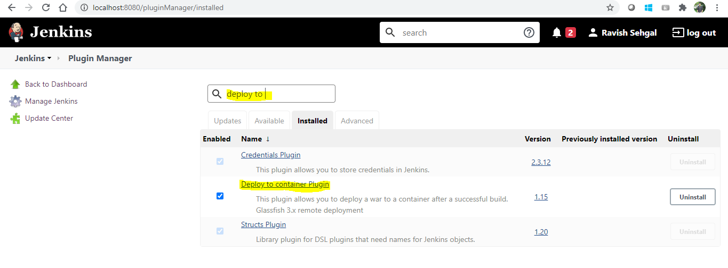

## Global tool configuration – Git

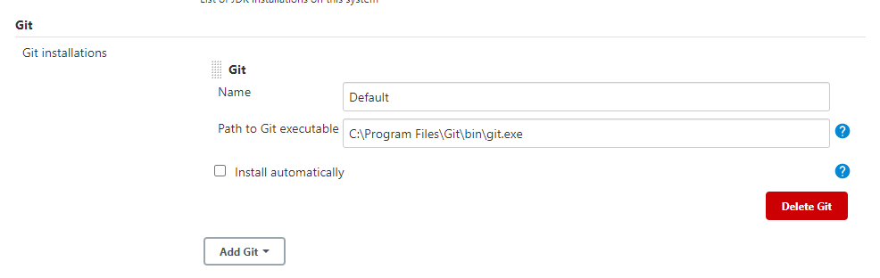

## Next we will create the free style pipeline as follows

## Configure git

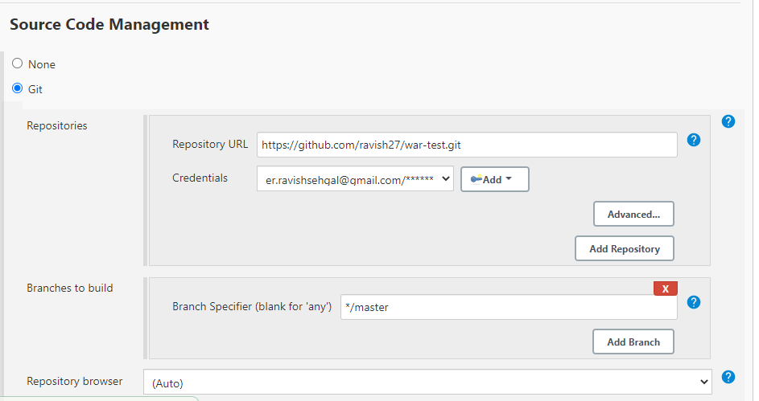

## Build step

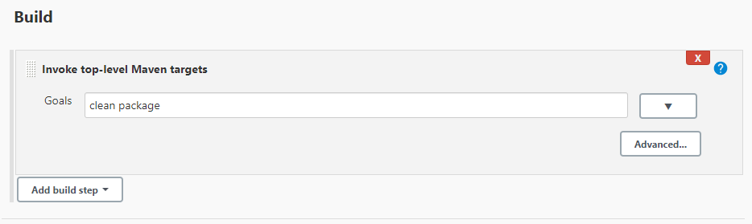

## Post build action

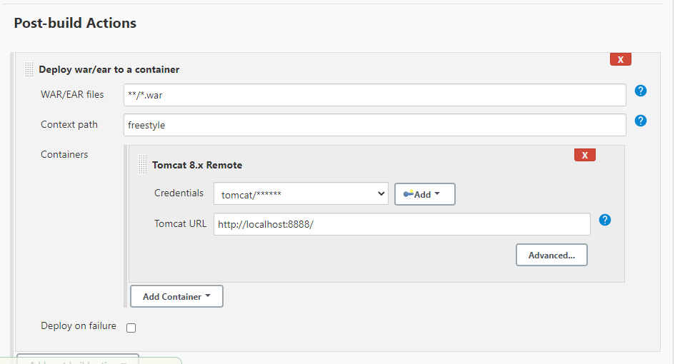

## Trigger build

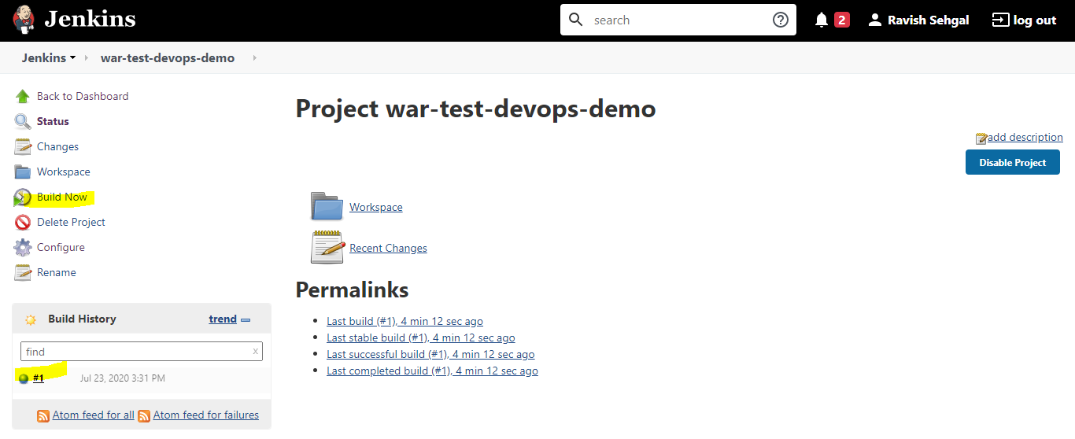

## Build output

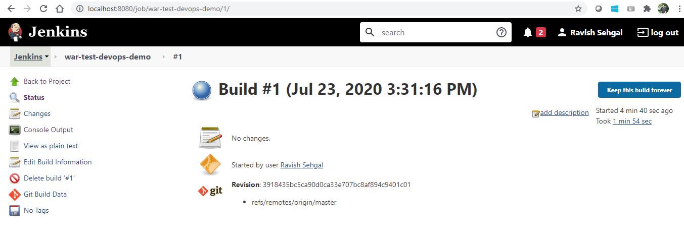

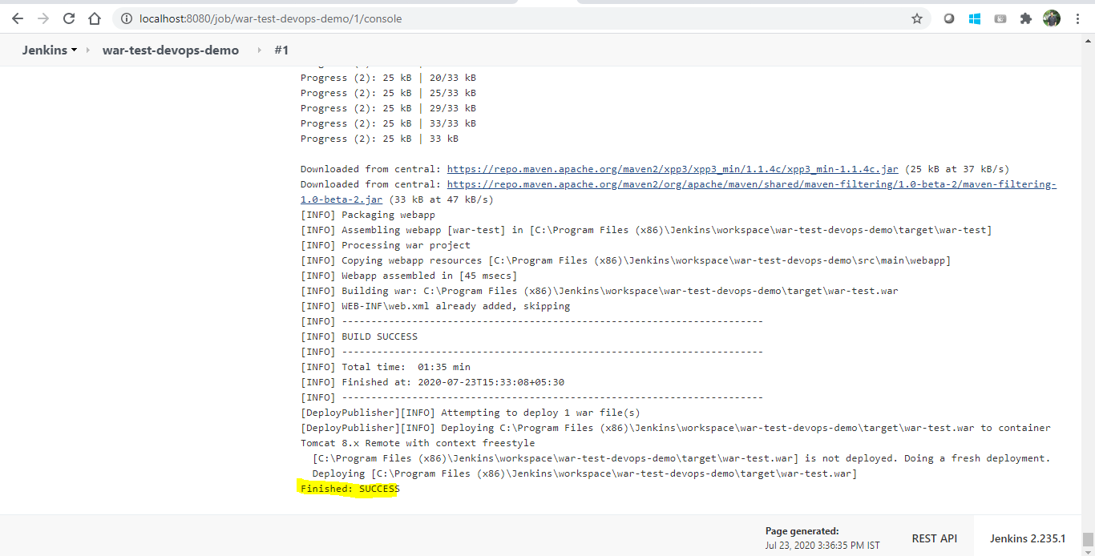

## Browse deployed app

